Problem 1

Total inflow - total outflow = supply/demand

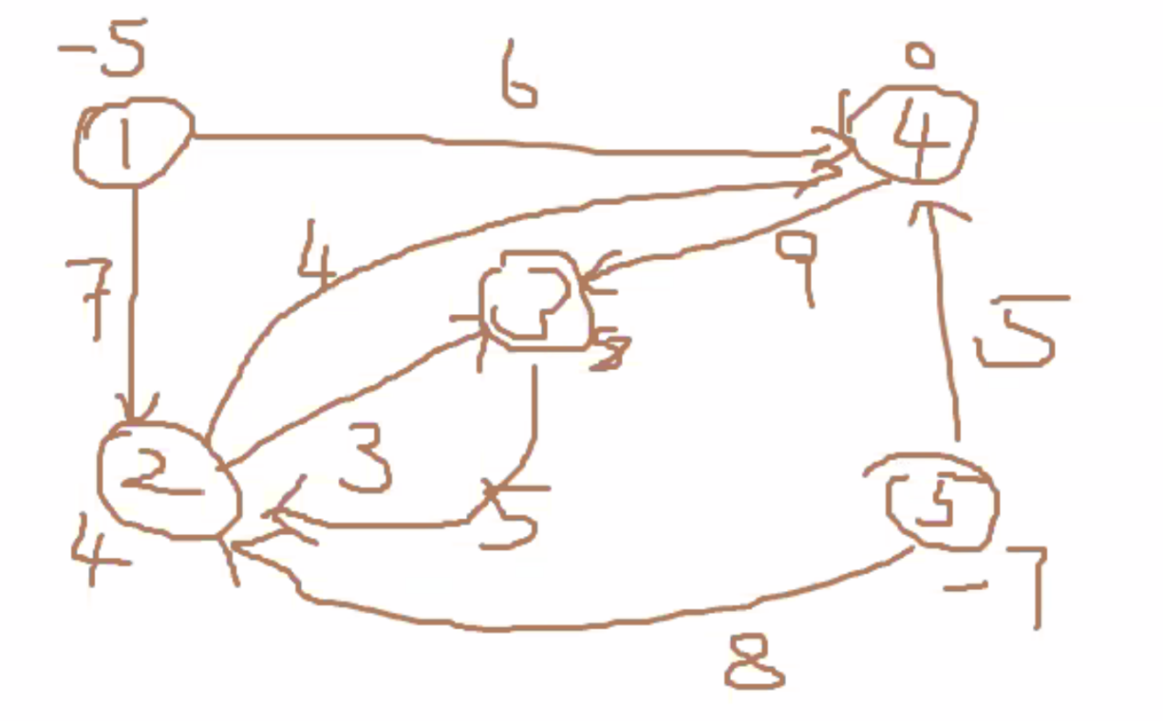

Problem 2

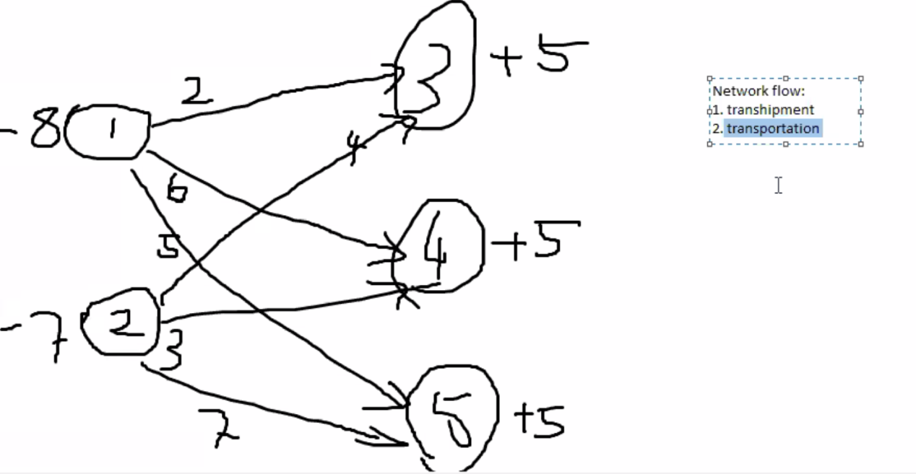

Problem 3

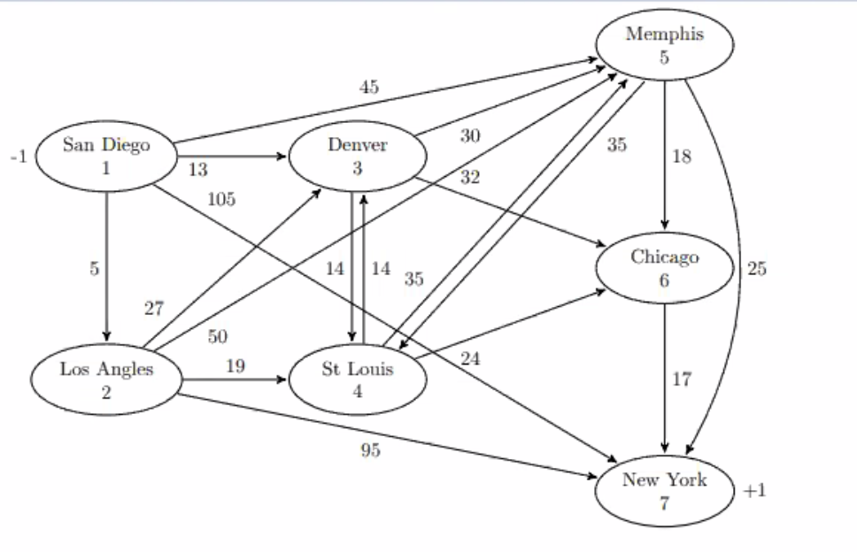

Let be the percentage of of goods shipped from location i to location j, where

Minimize

S.t.

Problem 4

Let be the number of cars transported from node i to node j, where i,j = 1,2,3,4,5

Minimize

S.t.

